Intelligent Banking Transaction Processing & Fraud Detection System

Course: BCSE302L – Database Systems | Laboratory guidelines: BCSE302P
ACID Compliance, Concurrency Control, Audit Logging and Performance Tuning
University: Vellore Institute of Technology, Vellore Department: School of Computer Science and Engineering Programme: B. Tech CSE (Data Science)
Submitted by: Sinchana B Kurkuri (24BDS0352), Prachi Pandurang Raddi (24BDS0389)

Project guide: Dr. Nithya N S

Academic year: 2026-27

Repository: Bank-Transaction-System-ACID-Compliance-Fraud-Detection-Performance-Tuning

Contents
1. Abstract 4
2. Introduction 5
3. Problem statement 5
4. Objectives 5
5. Scope 6
6. Existing versus proposed system 6
7. System requirements 7
8. Architecture 8
9. ER model and relational schema 9
10. Normalization and constraints 11
11. Banking transaction implementation 11
12. ACID compliance 12
13. Isolation and concurrency control 12
14. Deadlock detection and retry 13
15. Fraud scoring mechanism and rules 13
16. Stored procedures, functions, triggers and views 14
17. RBAC and audit logging 15
18. Indexing and query optimization 17
19. Implementation methodology 17
20. Dashboard walkthrough 17
21. Testing methodology 18
22. Actual test results 19
23. Performance measurements and limitations 19
24. Screenshots and exact capture instructions 20
25. Challenges and resolutions 25
26. Limitations 25
27. Future scope 27
28. Conclusion 27
29. References 27
30. Appendix: setup, execution and evidence 28
A. Windows setup and explicit lifecycle 28
B. Focused dashboard tests 28
C. Evidence map 28
Appendix D Database creation operations and retained outputs 34
Representative CREATE TABLE and foreign keys 34
Sample INSERT and source-defined reference values 34
Join aggregation and subquery examples 34
Actual retained deposit and transfer outputs 34
UPDATE DELETE and transaction boundaries 35
Appendix E Corrected ER detail sheets 36
Banking relationships 36
Fraud detection relationships 37
Audit access and approval relationships 38

Abstract
This project implements a MySQL8.4 banking transaction laboratory that connects financial operations with consistency checks, detective fraud evaluation and an auditable event history. Customers, accounts, deposits, withdrawals, transfers, loans and approval requests are represented by related InnoDB tables and public stored procedures. Ordered row locks and explicit transaction handlers protect multi-account transfers. Completed ledger entries are immutable, while audit and fraud triggers participate in the same transaction as the banking operation.
A localhost dashboard makes the implementation observable through live forms, tables, charts and a guided academic demonstration. The application reuses the native MySQL client and existing procedure contracts rather than duplicating financial logic in Python. It displays historical isolation/deadlock/performance evidence separately from live database observations. An owned disposable schema lifecycle protects established project databases during evaluation.
Previously executed safe SQL populations achieved632 Standalone and688 Integrated passes with no failures. The dashboard delivery added nine HTTP boundary tests, a32-check real database HTTP workflow and an actual browser walkthrough. Six banking invariants passed. These overlapping counts are not combined into a single inflated total. Restricted Customer/Teller/Manager login behavior has separately recorded PR9 evidence. Authenticated Auditor behavior, current standard-role deployment, crash recovery and representative large-data performance conclusions remain outside the demonstrated dashboard scope.

Introduction
A banking operation is more than an update to a balance column. The application must preserve an interpretable ledger, reject invalid transitions, coordinate concurrent writers and make the resulting changes attributable. A transfer is a useful example: debit and credit must form one transaction, concurrent requests must not lose updates, and audit or fraud side effects must not survive a failed financial operation independently.
The project treats these requirements as executable database contracts. Its public routines are the mutation boundary; constraints protect structural rules, guards protect immutable and minimum-balance behavior, and reconciliation checks evaluate consistency after realistic workflows. The dashboard allows an evaluator to inspect these contracts without manually writing SQL. It is an educational local application, not a production banking service.

Problem statement
Design and demonstrate an integrated transaction system in which banking, fraud evaluation, audit and authorization operate together without contradicting one another. Specifically, prevent partial transfers, maintain balance/ledger agreement, attribute changes to the authenticated session, detect supported risk signals and expose verifiable results. A second problem is methodological: installation and testing must not damage existing databases or confuse old evidence with newly executed checks.

Objectives
  - Provide public routines for registration, account lifecycle and financial operations, with meaningful MySQL errors and explicit transaction ownership.
  - Maintain Completed ledger, transfer-pair, balance-chain, minimum-balance and audit-watermark invariants.
  - Evaluate actual configured fraud rules automatically after ledger insertion.
  - Preserve customer ownership and employee branch rules while documenting the difference between authorization logic and authenticated least privilege.
  - Demonstrate rollback, isolation, ordered locking, real deadlocks and retries using bounded owned-database tests.

  - Compare unchanged Baseline/Optimized index profiles using measured samples and EXPLAIN, without assuming that every index improves every query.
  - Deliver a reproducible offline dashboard, evidence and academic explanation.

Scope
Implemented database scope includes sixteen banking/fraud tables, helper test objects in a separate schema, banking public/private routines, seven specified fraud functions, guards, audit/fraud triggers, identity-filtered views, RBAC installer source and optional performance indexes. Existing loan and approval workflows remain available through the database and CLI.
The dashboard's live mutation scope is registration, opening, deposit, withdrawal, transfer, fraud review and the bounded development-mode rollback probe. It also provides history, statements, audit inspection, metadata and live reconciliation. Isolation, deadlock and latency charts use labeled verified evidence rather than running long experiments during HTTP requests.
The model assumes single-owner accounts and one currency. There is no real payment network, payment gateway, production identity verification, internet deployment, machine-learning fraud claim or new location/time-anomaly rule.

Existing versus proposed system
For conceptual comparison, a minimal CRUD teaching application would let its application code update balances and display success without independently checking a ledger or concurrent behavior. That conceptual baseline is not an external product measured in this report.
The proposed implementation puts financial behavior behind database routines, records Completed and eligible Failed transactions, makes audit and fraud effects transactional, and provides explicit invariant checks. Its dashboard displays observed results and native errors instead of optimistic success messages. Test targets are collision-checked disposable databases, not a shared production-like schema. This makes failures reproducible and their scope explainable.

System requirements
Table 1. System requirements and measured environment

Component | Requirement / measured configuration
Database | MySQL8.4 with InnoDB, CHECK constraints, JSON, window functions and stored objects; measured8.4.11
Application | Python3.10+ standard library; measured3.12.14
SQL access | Native mysql executable; external private client option file
Windows tools | PowerShell5.1+; executable paths may contain spaces
Browser | Modern browser with Fetch, CSS Grid and JavaScript; actual UI tested in installed Microsoft Edge
Optional browser QA | Playwright with installed Edge; not an application dependency
Network | Loopback127.0.0.1 only; no CDN, cloud service or package download required
Hardware evidence | Intel Core Ultra5 125H,14cores/18logical processors,16568156160bytes RAM; Windows NT10.0.26200.0
Flask was absent from the available runtime. The permitted standard-library HTTP-server fallback was used instead of introducing an installation dependency. This choice is appropriate only for the bounded local evaluation: Python's http.server documentation cautions against production use [R5].

Architecture
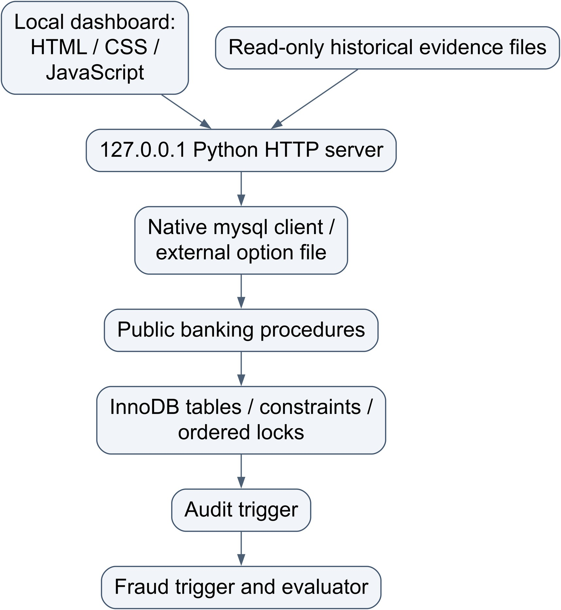
Figure 1. System Architecture
The browser cannot choose a database, supply SQL, invoke a shell, provision accounts or drop schemas. The server accepts only fixed operation schemas and validates inputs using the existing CLI parser. The active session file supplies the generated database and owner token. Startup verifies the owner marker before serving requests. State-changing requests require POST, JSON, an exact local Origin and a CSRF token; the Host header is restricted to the actual loopback address and port. Static resources are served from a fixed allowlist.
The native client receives UTF-8 SQL through stdin with no shell interpolation. All financial mutations use public routines. Read-only metadata is obtained from information_schema. A request lock prevents overlapping dashboard actions and snapshots from confusing an instructional before/after comparison; genuine concurrency is established separately by the existing native-session experiments.

ER model and relational schema
The Integrated SQL defines 16 business tables, 122 attributes and 26 foreign-key roles. The corrected ER overview below and the readable detail sheets in Appendix D represent those definitions. Separate edges identify transaction counterparties, loan disbursement, approval source/destination and actor roles. All FK actions are RESTRICT. Parent participation permits zero children; nullable FKs permit zero or one parent, while NOT NULL FKs require one. Complete attributes and key markers appear in the diagram. Audit_Log.table_name/record_pk is not a generic FK.

Figure 2. Entity Relationship Model

Table 2. Relational schema and important references

Relation | Key and important references
Branches | branch_id PK; unique synthetic IFSC code
Employees | employee_id PK; branch FK; unique email; Teller/Manager/DBA
Customers | customer_id PK; unique email, phone and proof; active/KYC attributes
Account_Types | account_type_id PK; unique name; rate and minimum balance
Accounts | account_id PK; customer/branch/type FKs; unique number; balance/status
Transactions | BIGINT transaction_id PK; account/counterparty/employee/ device/location references; transfer group; amount/status/ reference
Loans | loan_id PK; customer FK; optional disbursement account FK
Fraud_Flags | flag_id PK; transaction/rule references; score, JSON evidence, review status
Audit_Log | BIGINT audit_id PK; JSON old/new values; session and optional actor FKs
Devices | device_id PK; customer FK; unique fingerprint; trust flag
Locations | location_id PK; geographical descriptive/coordinate columns
Fraud_Rules | rule_id PK; unique code; weight, parameters and active flag
Account_Risk_Profile | account_id PK/FK; score, level and evaluation/update times
DB_User_Map | db_login PK; exactly one Customer or Employee FK according to actor_type
Transaction_Approvals | approval_id PK; source/destination account FKs; requester/ decision/group linkage
Fraud_Ground_Truth | transaction_id PK/FK; synthetic label for evaluation datasets
Transactions.related_account_id is an optional second Accounts reference. Approvals have two distinct Accounts references, not a single composite account. Additional employee references identify transaction staff, reviewers and decision makers. Audit_Log.table_name/ record_pk is a polymorphic audit label, deliberately not a generic FK. The owner-marker table and helper schemas are test infrastructure, not business entities. Ground-truth storage does not imply measured classifier precision/recall; no such accuracy claim is made here.

Normalization and constraints
Separate Branches, Employees, Customers and Account_Types relations avoid repeating descriptive data in every transaction. A transaction references an account instead of duplicating its owner's complete identity. Fraud rule catalog and flag instances separate policy configuration from observations. Unique candidate keys prevent duplicate natural identifiers, and FKs maintain referenced entity existence using RESTRICT actions.
The design is substantially normalized, but intentionally stores derived state: Accounts.balance supports efficient locked updates, Account_Risk_Profile stores summary risk and Audit_Log/Fraud_Flags contain historical JSON evidence. Such choices require reconciliation and clear lifecycle rules rather than an unsupported claim that every stored attribute is an independent third-normal-form fact.
CHECKs enforce nonnegative balances, positive financial amounts/principal/tenure, score bounds and consistent audit actor fields. UNIQUE constraints prevent repeated reference numbers, duplicate transfer leg types within a group, and duplicate transaction/rule flags. Procedure checks and triggers enforce cross-table minimum balances and legal transitions that simple row-local constraints cannot express.

Banking transaction implementation
Registration validates customer attributes and uses synthetic demonstration data. Opening checks an active customer and valid branch/type, creates the account and posts a Completed opening Deposit. That opening convention makes the ledger explain the balance from inception instead of requiring an unexplained initial balance offset.
Deposit/withdraw routines validate amount/channel/staff and lock the account. Withdrawal preserves the type's minimum balance. Transfers lock two Accounts rows in canonical account-ID order, compute balances under those locks and use relative updates. They write one TransferOut and one TransferIn with the same UUID, equal amounts and mirrored account/counterparty fields. Device/location metadata is stored only on the debit transfer leg. Public signatures are unchanged.
Transfers of at least100000 require approval; a request moves no money. A decision locks the request and requires an appropriate active Manager distinct from the requester. Approval uses

the internal transfer path within the caller's transaction; rejection closes the request without moving funds. Loan disbursement, when routed, creates a Deposit rather than silently adjusting the account.
Eligible business rejections5003/5004/5005/5006/5010 can create Failed ledger rows after rollback in a separate small transaction. This does not mean a partial Completed transfer. Deadlock/timeout and lab-injected failures are not recorded as business Failed transactions. The dashboard shows actual before/after counts so this distinction remains visible.

ACID compliance
Atomicity. Public mutation procedures own transaction control and rollback handlers. The live dashboard's bounded transfer mode1 actually raises5016 after debit work. The HTTP test observed identical balances, ledger/audit/flag counts and aggregate profile risk before and after. Audit and fraud changes participate in the same rollback; neither is committed independently by a trigger.
Consistency. Six executable invariants inspect derived state rather than assuming that successful SQL means a valid system. They cover balance/ledger equality, per-account balance_after chains, paired transfers, minimum-balance rules, audit watermark coverage and the newest Completed balance_after.
Isolation. Ordered locking protects concurrent transfers. Existing experiments also record dirty-read differences at all four supported levels. Snapshot reads and locking reads are different mechanisms; observed behavior must be tied to the actual statement and schedule rather than an isolation-level label alone [R1].
Durability. Prior measured settings included flush-at-commit1, sync_binlog1 and binary logging ON, and committed changes remained visible across separate native connections. This demonstrates committed persistence in normal operation, not power-loss or crash-recovery certification. The dashboard does not restart MySQL.

Isolation and concurrency control
The verified two-session dirty-read probe held an uncommitted +7 balance change for4seconds, then rolled back. The reader started after1second with a1second lock timeout. READ UNCOMMITTED observed100382.00; READ COMMITTED and REPEATABLE

READ observed the committed100375.00. SERIALIZABLE's read blocked and returned actual 1205. The dashboard reproduces the retained native output as historical evidence, not an animation claimed to be a new experiment.
Bounded ordered Quick used two actual sessions with five opposite-direction transfers each. Ten operations produced twenty Completed ledger legs; six invariants passed afterward. These observations support the specified smoke workload only, not a universal claim of deadlock freedom for arbitrary database operations. The server serializes ordinary GUI requests and deliberately provides no endpoint that launches a stress grid or changes global isolation.

Deadlock detection and retry
The real comparison created a cycle using EXP10's temporary database-only mode3 first-lock scheduling pause. One native session received1213 and one completed. The original routine was restored afterward; ordered mode and shipping source were unchanged. An earlier uninstrumented run did not deadlock and was retained as a failed expectation rather than relabeled as success.
The public retry wrapper retried whole transactions after actual1213/1205, recorded its retry after rollback and used bounded randomized backoff. The verified pair of retry calls completed and produced a committed DEADLOCK_RETRY row. Error1205 is a wait-timeout observation, not proof of a cycle; the project's procedure handler explicitly rolls back its transaction. InnoDB deadlock handling and application retry should be considered together [R2].

Fraud scoring mechanism and rules
The engine is deterministic rule-based detective fraud evaluation, not a learned classifier. The AFTER INSERT fraud trigger calls the evaluator for Completed transactions. It rebuilds risk from transaction facts and active rule parameters, writes unique transaction/rule flags with evidence JSON and updates a profile maximum. It does not block the banking transaction on a risk classification.
Approved helper contributions are untrusted/missing device+20 and digital channel+10. The established small digital/untrusted helper probe scores30. Amount≥5000 adds20 in the helper

and amount≥10000 adds35. The evaluator supplies profile input0, preventing a score it has just stored from feeding back into the same transaction.
Table 3. Active fraud rule catalog

Active catalog rule | Threshold | Added weight
HIGH_AMOUNT | amount≥5000 | 20
UNTRUSTED_DEVICE | missing device or trust false | 20
DIGITAL_CHANNEL | Online or Mobile | 10
HIGH_ACCOUNT_RISK | accumulated transaction-local score≥60 at this rule | 25
RAPID_ACTIVITY | at least3 Completed transactions in10minutes | 25
The helper base and matched catalog weights are distinct additive stages. Thus helper30 is not a promise that the final catalog score is30. Scores are capped100; levels are Low below30, Medium below60, High below85 and Critical otherwise.
In the verified controlled normal scenario, a trusted Branch deposit100 with only two recent Completed rows produced no flags. In the controlled suspicious scenario, a missing-device Online deposit6000 reached Critical100 and generated matched-rule evidence. The retained 23 October HTTP workflow independently observed the latter result. The page displays persisted values instead of hardcoding100.
Two actual reevaluations without changed facts preserved flag count and summed scores in the prior workflow. A profile is a maximum over evaluated events and must not be confused with the selected transaction's score. Distance and odd-hour functions exist as diagnostics, but there is no active location-change or time anomaly rule in the seed. No such automatic detection is claimed.

Stored procedures, functions, triggers and views
Public banking routines provide validated operations; private sp_internal_* helpers avoid transaction control so the caller owns atomicity. Functions include balance/available-balance/ interest/reference/masking/approval helpers and the seven specified fraud functions: distance, z-score, count window, odd hour, account age, transaction risk score and risk level. Their signatures are checked by existing regressions.

Six guards protect minimum balances, immutable ledger/audit rows, device ownership and self-counterparty rejection. Nine audit triggers cover Accounts, Transactions and Loans INSERT/UPDATE/DELETE; Transactions UPDATE/DELETE auditing is normally unreachable because guards reject those operations. Fraud is ordered FOLLOWS the Transactions INSERT audit trigger. The ordering is verified from installed ACTION_ORDER, not only from source comments. MySQL supports explicit ordering between same-event/timing triggers [R3].
The views are v_customer_account_summary, v_transaction_activity and v_fraud_case_queue. The dashboard shows their installed DEFINER metadata. Source files and build/file_order.txt preserve A/B dependency order: tables, FKs, functions, procedures, guards/audit/watermark, rules/fraud trigger, seed and views. RBAC deployment and optional indexes are separate explicit operations.

RBAC and audit logging
The database role design covers Customer, Teller, Manager and Auditor. Public procedure EXECUTE grants are explicit; private helpers and wildcard EXECUTE are not application permissions. Identity resolution follows actual USER() through DB_User_Map, with documented fallback behavior. Application roles require a correct mapping; selecting a role label in a GUI would not authenticate anyone. MySQL roles represent collections of privileges and must actually be granted and activated for a restricted login [R4].
Customers receive own summary/activity and approved public financial/statement APIs. Staff activity is active and branch-filtered. Managers have the fraud queue and manager APIs but no Audit_Log SELECT grant; the customer-summary view does not become an all-account view merely because a Manager can SELECT it. Auditor receives read-only approved information, not statement/mutation EXECUTE. Unmapped auditor activity may be empty under the implemented identity filters.
The current dashboard is a prominently labelled privileged administrative walkthrough; it does not authenticate a Customer, Teller or Manager merely by accepting an employee ID. Separate retained PR9 verification executed authorized temporary restricted Customer/Teller/Manager logins successfully, with 115 acceptance diagnostic passes and no failures. Auditor login and deployment to existing standard accounts remain unverified. No user, role or grant was created for this report revision.
Audit rows include entity, action, old/new JSON, performed_at, session USER() and resolved actor. The watermark records when trigger coverage began. Earlier loaded rows are not

falsely treated as missing new audit events. UPDATE/DELETE guards do not make the log safe from a privileged DBA who can drop triggers or truncate tables. The report does not describe it as tamper-proof.

Indexing and query optimization
B0 contains only PK, UNIQUE and FK-required indexes. The Optimized profile explicitly adds the existing seven performance indexes. Neither page visits nor dashboard actions silently install them. The live Architecture/Performance pages show current metadata, whereas latency charts load a separate historical Baseline/Optimized measurement run.
EXPLAIN is used to identify access paths, ordering and possible index selection. An index being available does not mean the optimizer should select it for a tiny table. Query timing and plan changes must be interpreted together rather than equating an index name with a speed improvement.

Implementation methodology
The work began by inspecting the integrated branch, prior evidence, public interfaces and safe lifecycle. Existing financial/fraud/security SQL was retained. The CLI was used as the reference adapter for argument validation, native process execution and public routine SQL. A standard-library server and offline frontend were added, then checked with syntax and HTTP boundary tests before any live mutation.
Live testing used one freshly generated owned database. Ownership was checked at startup; operations were made through HTTP and public procedures. Edge browser tests exercised the actual DOM, forms, navigation and responsive layout. Only targeted dashboard tests were rerun after UI changes. The large historical SQL suite was not repeated unnecessarily because production SQL was unchanged.

Dashboard walkthrough
The current interface is titled Intelligent Banking and Fraud Detection. Its twelve destinations are grouped into Banking, Fraud and Database lab. Customers & Accounts and Banking Transactions use tabs so only one operation form is visible at a time. Supporting tables and technical output are collapsed. Draft values survive refresh and navigation, returned IDs propagate to later forms, and pending actions prevent duplicate submission. Live counts and persisted risk come from MySQL; the guided walkthrough has Previous/Next controls.

An evaluator registers a synthetic customer, opens an account and uses the actual returned IDs. The selected new customer propagates to opening; the new account becomes a sensible banking default. Deposit, withdrawal and transfer forms show native procedure output, before/after balances and ledger/audit/fraud count effects. Statements and history use the same database and server authorization.
Fraud Detection shows the latest persisted matched-rule score, classification, catalog thresholds and JSON evidence. Its Online6000 action posts a real public deposit. The normal trusted-device comparison is explicitly previously verified evidence, since provisioning a controlled trusted device is not a public banking operation. Fraud Review filters status/risk and invokes real legal transitions.
ACID provides a bounded live5016 rollback probe and reconciliation. Concurrency and Performance show labeled captured output; Audit shows live old/new JSON. RBAC explains the actual source contract and pending authentication test. The Architecture section is populated from information_schema, and Verification separates historical regression populations from its live six-invariant button.

Testing methodology
Testing has three new layers. Nine standard-library HTTP tests verify the shell, CSRF rejection, foreign Origin/Host rejection, absent arbitrary-SQL/traversal routes, JSON boundary, allowed POST and refusal of cleaned/protected session records. These use a fake adapter only for request-boundary unit testing and are not presented as database proof.
The real HTTP runner uses the running owned dashboard and has no SQL interface of its own. It registers/opens, executes financial operations, checks balances, statements, native rejection, suspicious flags and manager review, then verifies rollback, audit order, all six invariants and evidence/metadata endpoints.
The real Edge test loads the page, traverses all twelve destinations, starts the guide, registers and opens through browser forms, checks actual-ID propagation, submits a live deposit, checks invariants, captures screenshots and verifies mobile overflow and uncaught JavaScript errors. A stored markup-shaped synthetic name is rendered as literal text, not HTML. Tests do not substitute mock balances for live banking observations.

Actual test results
Historical results below are explicitly previous final-demo executions, not new dashboard reruns. Populations overlap and must not be summed.
Table 4. Actual test result populations

Population | PASS | FAIL | Classification
Standalone SQL | 632 | 0 | Previously verified
Integrated SQL | 688 | 0 | Previously verified actual A+B runtime
CLI workflow | 41 | 0 | Previously verified
ERROR1222 seed regression | 25 | 0 | Previously verified
Dashboard HTTP safety tests | 11 | 0 | Executed 27 October 2026; unit boundary/startup tests
Real MySQL HTTP workflow | 32 | 0 | Retained real execution, 20/23 October 2026; not rerun for this revision
Extended browser workflow | 23 | 0 | Retained real execution, 20/23 October 2026; not rerun for this revision
The HTTP workflow opened20000, deposited100, withdrew25 and transferred50, observing20025.00. A6000 suspicious deposit produced actual matched flags with maximum score100. Review advanced an actual flag through UnderReview to Confirmed. The5016 rollback snapshots were identical. All six reconciliation results were PASS with0 violations: I1, I1b, I2, I3, I4 and I5. The browser added another public deposit and subsequent consistency is checked before owned cleanup.
Earlier runtime summaries retained two missing role-deployment checks. Later authorized PR9 verification separately tested temporary restricted Customer/Teller/Manager logins; this does not deploy standard roles into the current dashboard session or certify an Auditor login. Historical populations remain separate and no SQL/scoring policy was changed for report preparation.

Performance measurements and limitations
The retained final-demo fixture contained10 Accounts,39 Transactions,132 flags and1 approval. Each of three fixed SELECTs had2 warmups and20 measured samples under each profile, for120 measured observations. Native session NOW(6) brackets excluded process

startup but included query/result production and interstatement client/protocol overhead; they are not isolated CPU timings.
Table 5. Baseline and Optimized performance measurements

Query | Baseline mean µs | Optimized mean µs | Plan observation
Recent account activity | 759.35 | 1226.40 | FK ref/filesort to account/time range/ backward scan
Open fraud queue | 926.05 | 1159.10 | Full scan/filesort retained
Requested approvals | 827.00 | 673.30 | ALL/filesort to status/requested index access
These are mixed tiny-data observations, not evidence of a general speedup. Warm cache, profile execution order, narrow/empty results and protocol noise limit inference. The dashboard preserves both the measured means and the limitations. Scaling conclusions require a separately bounded larger synthetic workload, randomized profile order and representative concurrency. No full benchmark grid was rerun for the GUI.

Screenshots and exact capture instructions
The following are fresh installed-Microsoft-Edge captures of the current dashboard, taken on 27 October 2026 from an already-owned disposable database. Navigation used GET requests only; API POST requests were blocked, so no banking mutation, benchmark or reconciliation button was executed for these captures. Visible counts and risk belong to that current dataset. Historical operation outputs and test results elsewhere remain dated historical evidence, not new screenshot-run results.

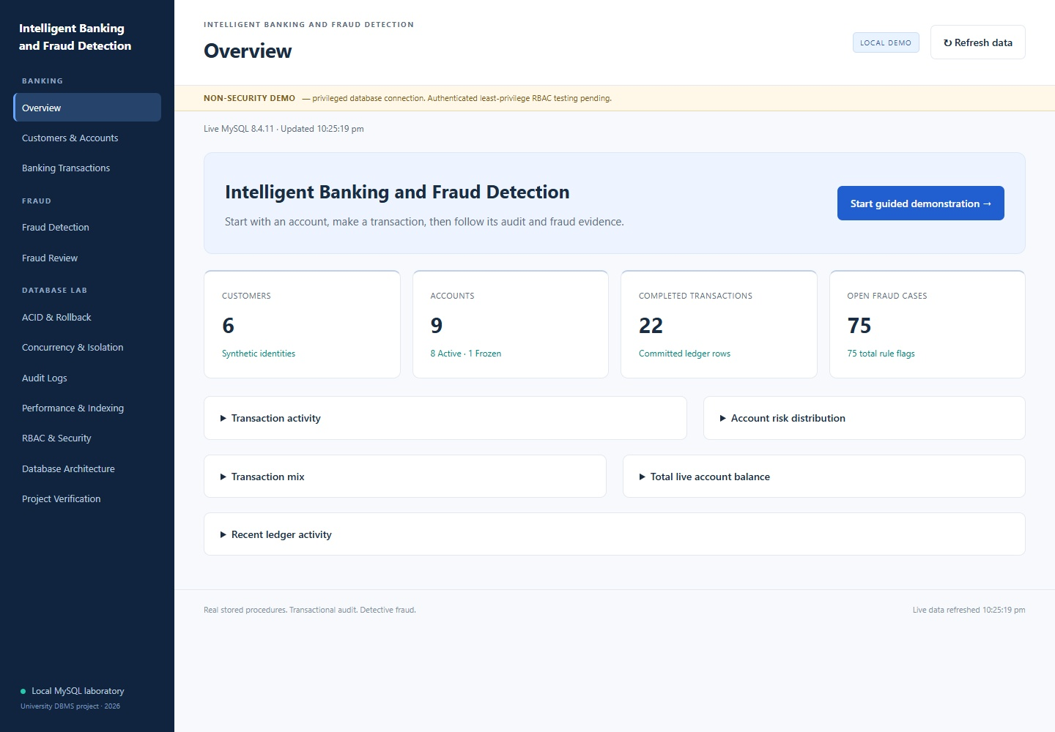
Figure 3. Live overview

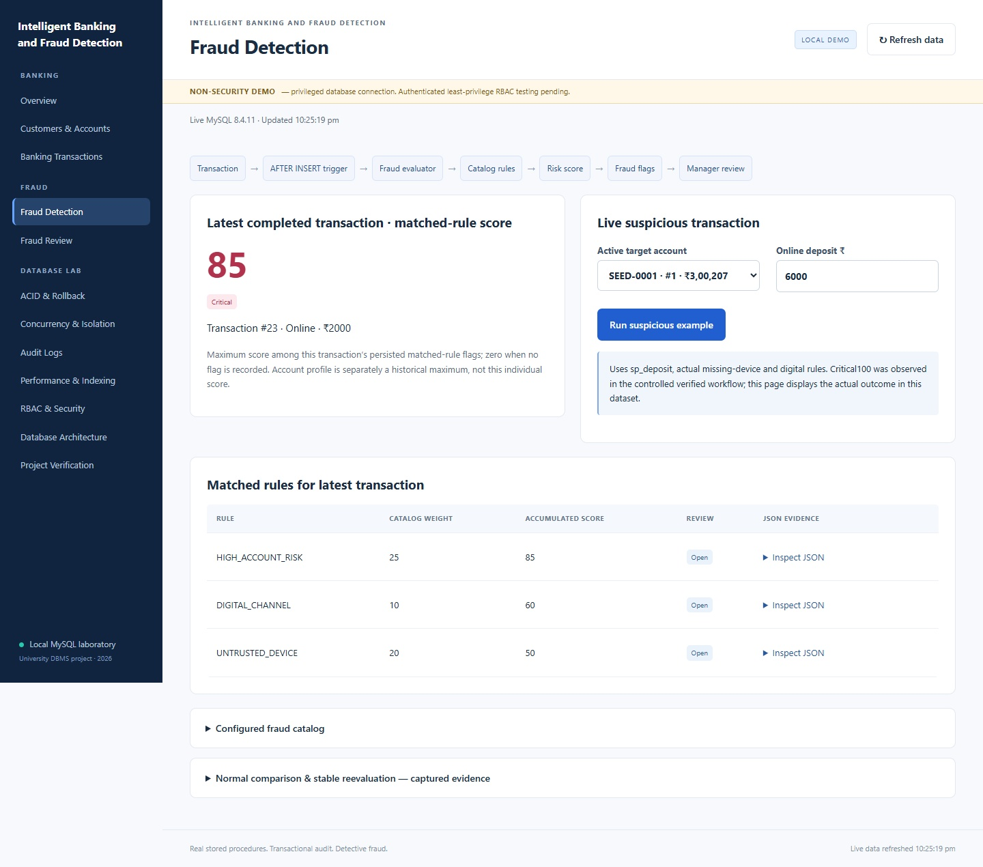

Figure 4. Current fraud pipeline and persisted matched-rule score

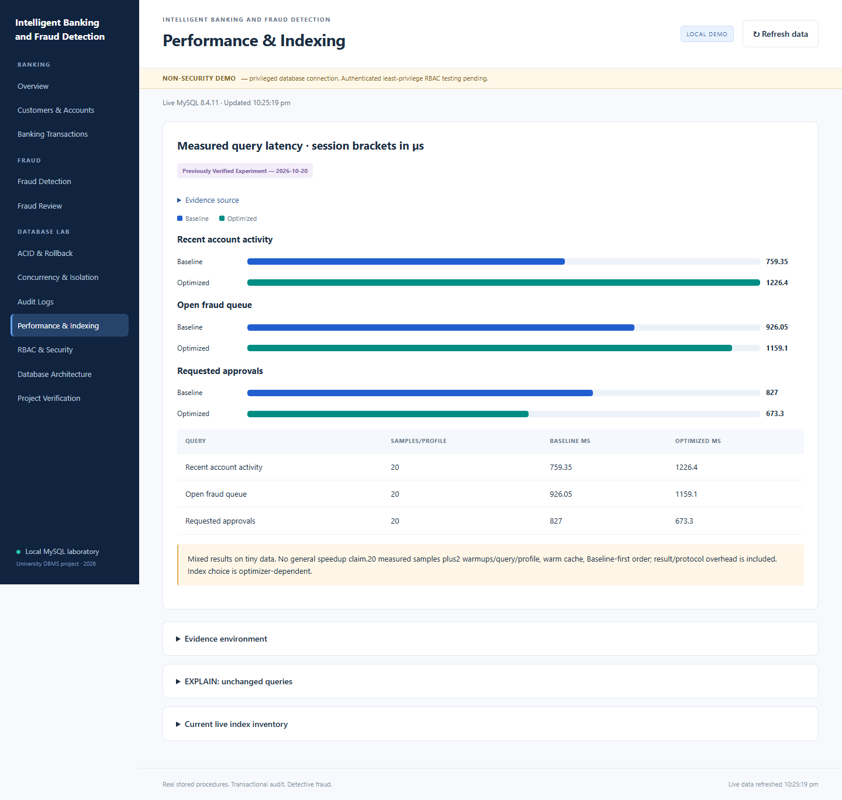
Figure 5. Measured Baseline/Optimized comparison

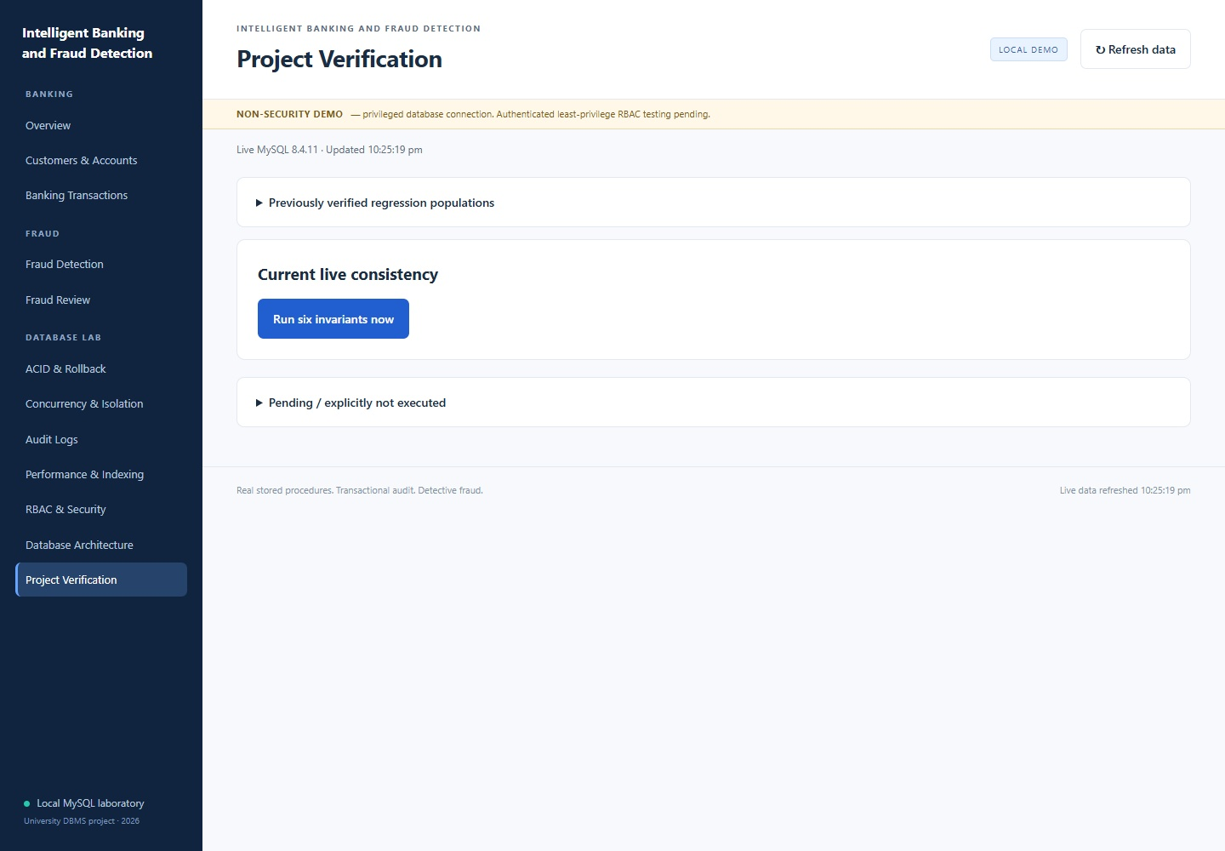

Figure 6. Current verification controls and retained test populations
Additional captures in that directory cover audit, architecture, a real submitted banking operation and mobile overview. To recapture for submission: start a fresh session, open127.0.0.1:5000 at1440px width, refresh the page, capture Overview, then run the guided financial workflow. Capture Fraud after the suspicious deposit, Audit after the transfer,

Verification after clicking Run six invariants, and Performance with its historical-source label visible. Expand a JSON details row when capturing evidence. Use the operating-system screenshot function or the optional browser test; never label an unexecuted example as a screenshot.

Challenges and resolutions
Integration initially exposed a SELECT/INTO arity error1222 in fraud evaluation; the merged correction and25-check seed regression protect that call chain. Earlier native-client installation, RBAC PREPARE syntax, view privilege evaluation and statement authorization fixes are retained in repository history and reports.
The final CLI work found PowerShell alias and scalar-result handling pitfalls and resolved them without changing database semantics. The GUI reuses the proven adapter to avoid repeating those risks. Its first syntax check caught an extra Python parenthesis before runtime testing; the correction passed import and HTTP tests. The application uses the Python standard-library HTTP server; Flask was absent in the original runtime and, so the allowed standard-library fallback avoided installation delay.
The in-app browser could not initialize. Bundled Playwright's downloaded Chromium was also absent; installed Edge was available and was used without downloading a browser. Real screenshots and browser assertions were therefore still obtained. Mixed latency results were preserved instead of being cosmetically described as an optimization success.

Limitations
This is a localhost privileged demonstration, not an authenticated internet bank. Retained PR9 evidence covers authorized restricted Customer/Teller/Manager logins, while the present dashboard still uses its administrative connection. New account/role testing or deployment needs separate approval. There is no user-login or role-switching illusion in the GUI. Stored API/view contracts retain their existing limits, including manager audit restrictions and auditor activity filtering.
Dashboard tables intentionally cap recent ledger/flag/audit rows for responsiveness; overview totals query all rows. The application serializes its own HTTP actions; it does not replace dedicated concurrency harnesses. Automatic location/time anomaly rules, learned detection accuracy, crash recovery and large-data speedup are not demonstrated. The standard-library HTTP server is not suitable for public production hosting. This corrected DOCX is the final report deliverable; no PDF was generated.

Future scope
Obtain approval for collision-checked temporary role/user provisioning and verify the GUI with native restricted Customer/Teller/Manager/Auditor sessions. Retain the current least-privilege surface rather than granting base-table access merely to make a page work. Extend tests before introducing a production authentication layer or deployment server.
Other future work includes a governed larger synthetic fixture, randomized performance comparisons, precision/recall evaluation against labeled ground truth, approved rule designs for new signals, and operator-executed recovery/PITR demonstrations. Each requires an explicit scope and truthful evidence, not an assumption that existing helper functions imply an implemented feature.

Conclusion
The project connects executable database contracts with an observable educational application. Public procedures preserve the transaction boundary, ordered locks coordinate financial writes, audit/fraud effects remain transactional, and six invariants expose consistency failures. The working localhost dashboard makes these behaviors demonstrable through actual forms, native results and evidence views. Its value lies in verified integration and explicit limitations rather than unmeasured claims of production security, fraud accuracy or universal speedup.

References
[1] A. Silberschatz, H. F. Korth, and S. Sudarshan, Database System Concepts, 7th ed. New York, NY, USA: McGraw-Hill, 2019.
[2] R. Elmasri and S. B. Navathe, Fundamentals of Database Systems, 7th ed. Boston, MA, USA: Pearson, 2016.
[3] R. Ramakrishnan and J. Gehrke, Database Management Systems, 3rd ed. New York, NY, USA: McGraw-Hill, 2003.
[4] J. Gray and A. Reuter, Transaction Processing: Concepts and Techniques. San Francisco, CA, USA: Morgan Kaufmann, 1992.
[5] R. J. Bolton and D. J. Hand, “Statistical Fraud Detection: A Review,” Statistical Science, vol. 17, no. 3, pp. 235–255, 2002. https://doi.org/10.1214/ss/1042727940
[6] V. Chandola, A. Banerjee, and V. Kumar, “Anomaly Detection: A Survey,” ACM Computing Surveys, vol. 41, no. 3, Article 15, 2009. https://doi.org/10.1145/1541880.1541882
[7] P. G. Selinger, M. M. Astrahan, D. D. Chamberlin, R. A. Lorie, and T. G. Price, “Access Path Selection in a Relational Database Management System,” in Proceedings of the 1979 ACM SIGMOD International Conference on Management of Data, pp. 23–34, 1979. https://doi.org/10.1145/582095.582099
[8] Oracle Corporation, MySQL 8.4 Reference Manual. Available: https://dev.mysql.com/doc/refman/8.4/en/
[9] Python Software Foundation, Python 3.12 Documentation. Available: https://docs.python.org/3.12/

Appendix: setup, execution and evidence

Windows setup and explicit lifecycle
$env:BANK_MYSQL_CNF = Join-Path $HOME '.bank_mysql.cnf'
$env:BANK_MYSQL_BIN = 'C:\Program Files\MySQL\MySQL Server 8.4\bin\mysql.exe'
$env:BANK_PYTHON_BIN = 'C:\Path To Python\python.exe'
$env:PYTHONUTF8 = '1'
powershell -NoProfile -File demo/start_demo.ps1 -SessionFile demo/out/dashboard-session.json
powershell -NoProfile -File demo/start_dashboard.ps1 -SessionFile demo/out/ dashboard-session.json
# Open http://127.0.0.1:5000. Stop only the dashboard with Ctrl+C when finished. powershell -NoProfile -File demo/start_demo.ps1 -Action Stop -SessionFile demo/out/ dashboard-session.json
Keep actual credentials outside the repository. The native client option file uses a private [client] section. No password is embedded in the commands or HTML. Use a new session filename for another run; do not delete historical evidence to reuse one. Start/Stop are explicit shell operations, never HTTP endpoints.

Focused dashboard tests
& $env:BANK_PYTHON_BIN -m unittest discover -s tests/dashboard -p 'test_*.py' # With a fresh owned dashboard already running:
& $env:BANK_PYTHON_BIN tests/dashboard/live_dashboard.py `
--evidence-dir evidence/reviews/final-dashboard/my-new-http-run # Optional: installed Edge + Playwright available on NODE_PATH:
node tests/dashboard/browser_smoke.cjs evidence/reviews/final-dashboard/my-new-browser-run
Test output directories must be new, preserving historical results. The live runner has no arbitrary SQL or protected-database option. Always stop the server and invoke ownership-checked Stop after testing. The prior full safe SQL/CLI orchestrator remains tests/demo/ verify_all.ps1; it was not rerun for unchanged production SQL in this GUI delivery.

Evidence map
- New HTTP assertions/results: evidence/reviews/final-dashboard/http-workflow-20261020-1/.

- Actual browser assertions/screenshots: evidence/reviews/final-dashboard/ browser-20261020-2/.
- Final six-invariant and cleanup records: see the dashboard implementation report.
- Historical SQL/CLI summary: evidence/reviews/final-demo/REPORT.md.
- Historical performance/isolation/deadlock source: evidence/reviews/final-demo/ runs/workflow-20261020-190002-497-51085f9cf61f46d4a5bbee110928b886/.
- Historical SQL per -file source: evidence/reviews/final-demo/runs/ isolated-20261020-185810-465-c1fcdcc71d0446e5a090e67884cd375f/test-populations.csv.
- Primary ER source: docs/er/er_core.mmd; live metadata adds the installed Account_Risk_Profile relation and all sixteen business tables.Appendix: Additional System Screenshots

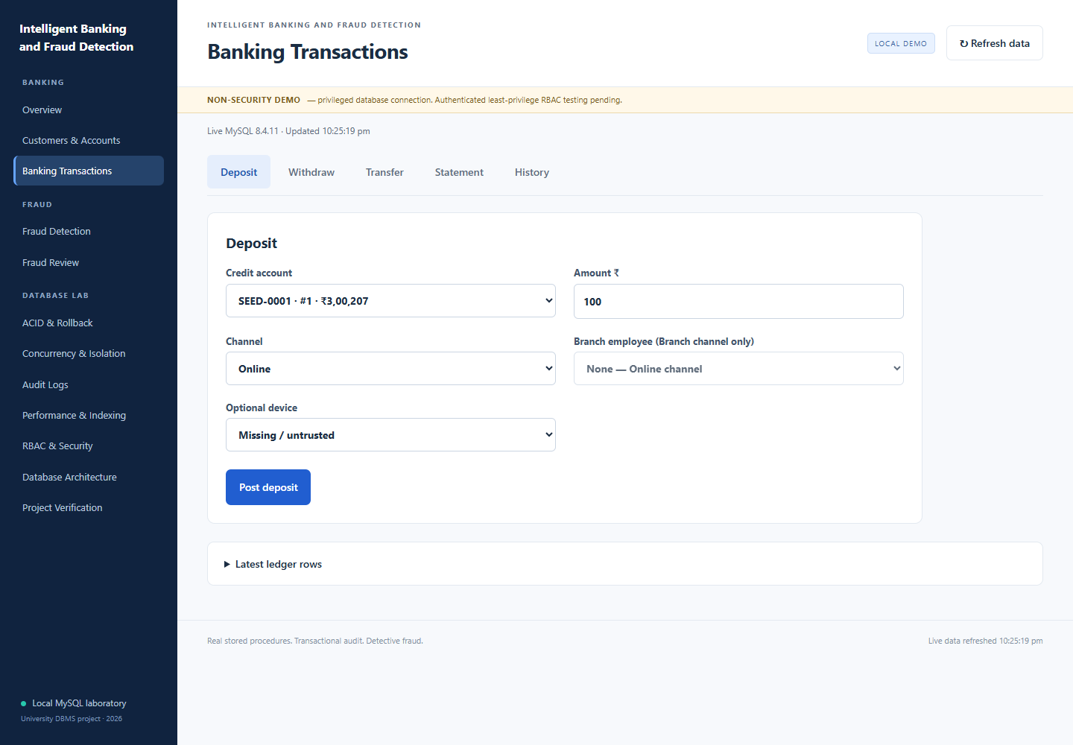

Figure 7. Banking transaction operations

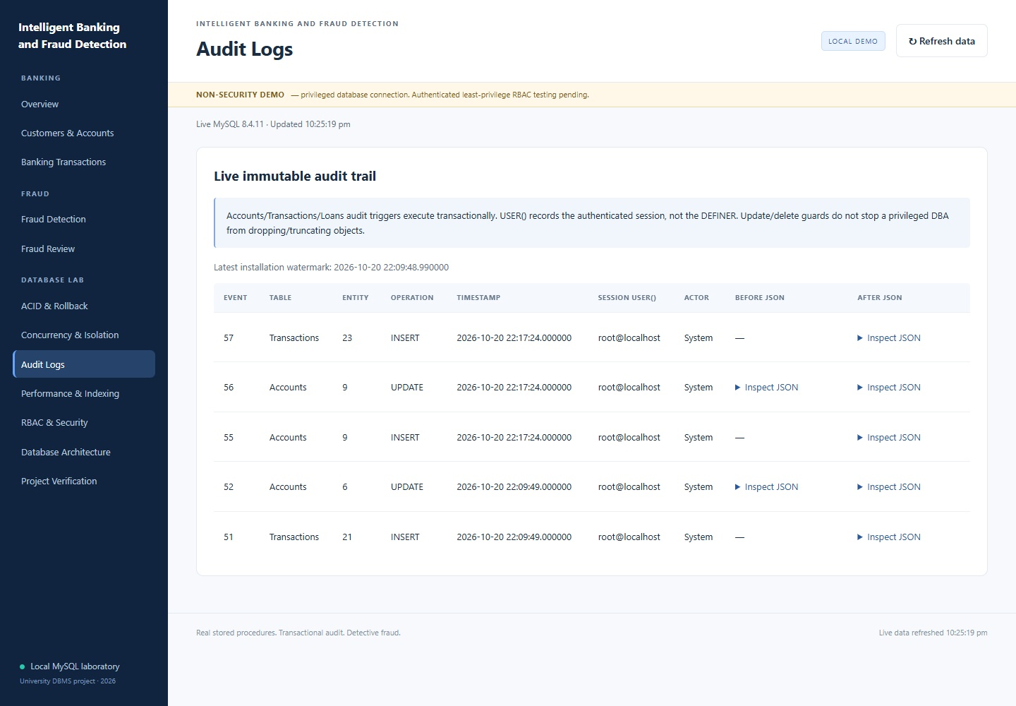
Figure 8. Audit logging

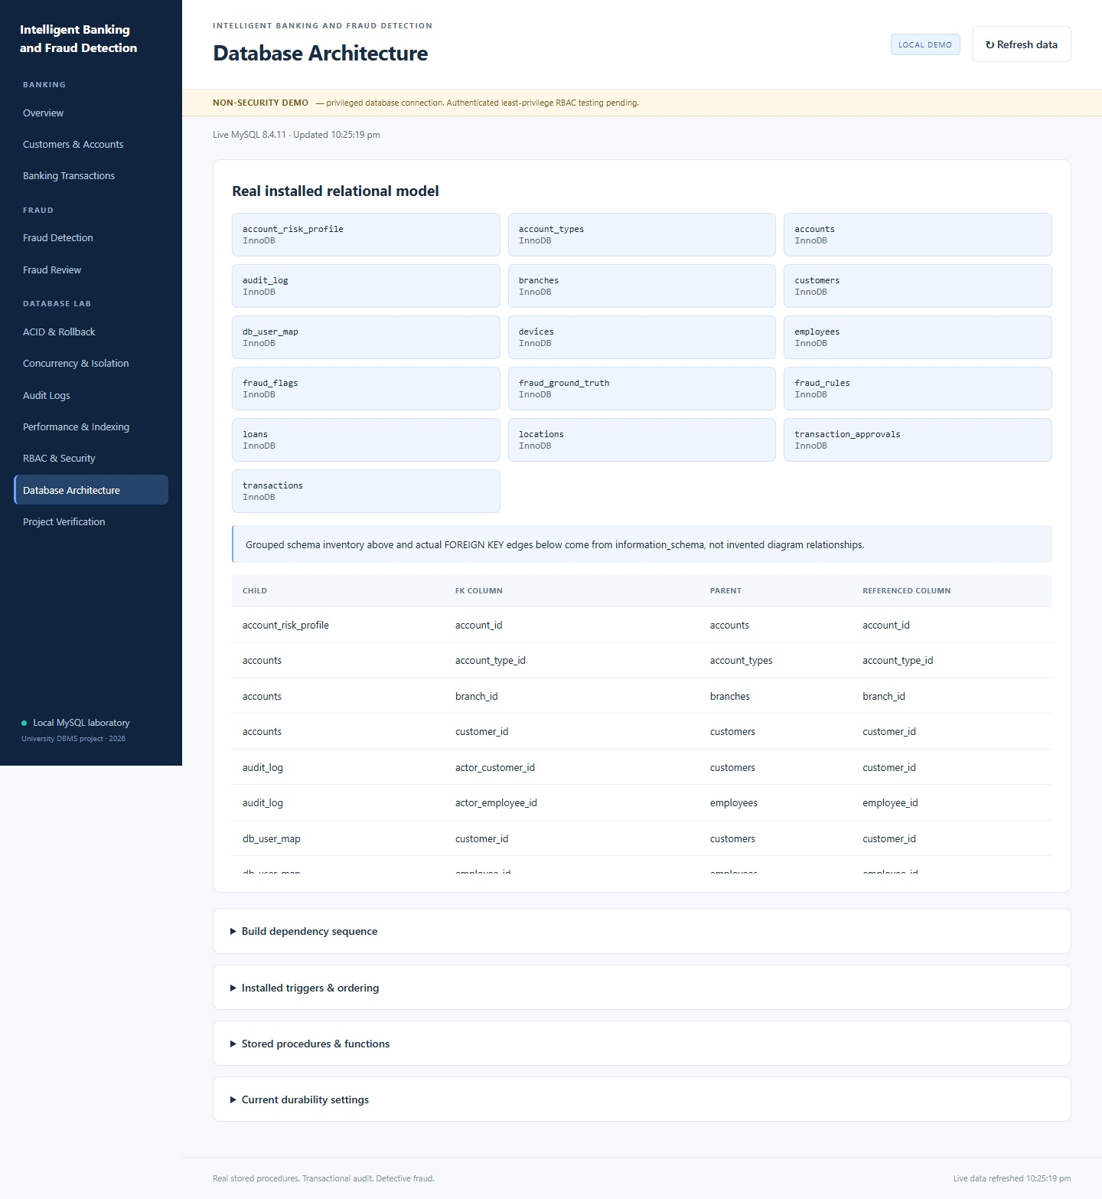

Figure 9. Database architecture and schema interface

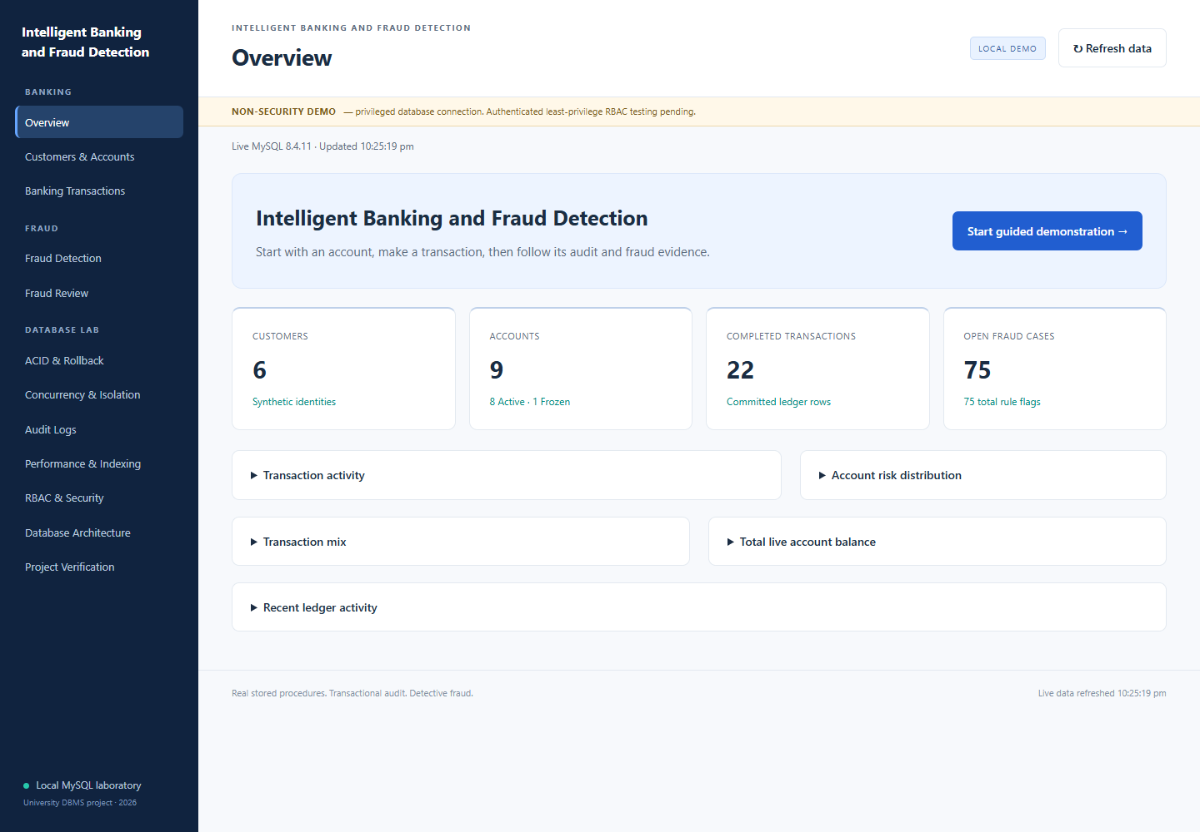

Figure 10. Current dashboard overview and navigation

Appendix D Database creation operations and retained outputs

Representative CREATE TABLE and foreign keys
CREATE TABLE Accounts (
account_id INT AUTO_INCREMENT, customer_id INT NOT NULL, branch_id INT NOT NULL,
account_type_id INT NOT NULL, account_number VARCHAR(20) NOT NULL, balance DECIMAL(14,2) NOT NULL,
status ENUM('Active','Frozen','Closed') NOT NULL DEFAULT 'Active', opened_date DATE NOT NULL,
CONSTRAINT pk_accounts PRIMARY KEY(account_id), CONSTRAINT uq_accounts_number UNIQUE(account_number),
CONSTRAINT chk_accounts_balance CHECK(balance>=0)
) ENGINE=InnoDB DEFAULT CHARSET=utf8mb4;
ALTER TABLE Accounts ADD CONSTRAINT fk_accounts_customer_id FOREIGN KEY (customer_id) REFERENCES Customers(customer_id) ON DELETE RESTRICT ON UPDATE RESTRICT;
ALTER TABLE Accounts ADD CONSTRAINT fk_accounts_branch_id FOREIGN KEY (branch_id) REFERENCES Branches(branch_id) ON DELETE RESTRICT ON UPDATE RESTRICT;
ALTER TABLE Accounts ADD CONSTRAINT fk_accounts_account_type_id FOREIGN KEY (account_type_id) REFERENCES Account_Types(account_type_id) ON DELETE RESTRICT ON UPDATE RESTRICT;
This exact implemented DDL demonstrates PRIMARY KEY, NOT NULL, UNIQUE, CHECK and separate named FOREIGN KEY constraints. MySQL/InnoDB and utf8mb4 are used for the A core tables; B table files inherit the target storage-engine default, so runtime InnoDB metadata must be checked. Raw loaders must run before triggers; the procedure-based tiny seed runs after triggers and creates normal ledger/audit rows.

Sample INSERT and source-defined reference values
INSERT INTO Account_Types(type_name,interest_rate,min_balance) VALUES
('Savings',3.50,1000.00),('Current',0.00,5000.00),
('Fixed Deposit',6.50,10000.00)
ON DUPLICATE KEY UPDATE interest_rate=VALUES(interest_rate),
min_balance=VALUES(min_balance);
These are the actual idempotent seed values from data/seed/01_reference_data.sql, not a newly executed result. Demonstration records and identification proof numbers are synthetic. Opening accounts uses sp_open_account and always posts a Completed opening Deposit.

Join aggregation and subquery examples
SELECT a.account_number,c.full_name,a.balance,a.status
FROM Accounts a JOIN Customers c USING(customer_id)
WHERE a.status='Active' ORDER BY a.account_id;
SELECT transaction_type,COUNT(*) AS rows_count,SUM(amount) AS total
FROM Transactions WHERE status='Completed' GROUP BY transaction_type;
SELECT account_id,account_number FROM Accounts
WHERE balance>(SELECT AVG(balance) FROM Accounts);
These valid schema-based examples demonstrate SELECT, filtering, sorting, a join, aggregation and a subquery. Outputs depend on the selected dataset and were not fabricated. The current database architecture/sample-data screenshots show actual runtime state. Retained native public-call outputs below are copied verbatim from the real 23 October HTTP workflow.

Actual retained deposit and transfer outputs
CALL sp_deposit(@aid,100.00,'Online',NULL,NULL,NULL,@tid,@bal);
SELECT @tid AS transaction_id,@bal AS balance_after;
transaction_id balance_after
23 20100.00
Source: evidence/reviews/dashboard-ui-20261023/http/deposit.json. The selected account had been opened with 20,000.00; this retained deposit produced 20,100.00.
CALL sp_transfer_funds(@from_id,@to_id,50.00,'Online',
NULL,NULL,NULL,0,@group_id,@debit_id,@credit_id);
SELECT @group_id,@debit_id,@credit_id;
transfer_group_id debit_txn_id credit_txn_id
14a89d44-cea7-11f1-9e2f-1cce51263d67 25 26
Source: evidence/reviews/dashboard-ui-20261023/http/transfer.json. The later retained balance was 20,025.00 after opening 20,000, deposit 100, withdrawal 25 and transfer 50. These IDs/UUID are historical observations, not universal identifiers.

UPDATE DELETE and transaction boundaries
CALL sp_update_customer(@customer_id,NULL,'Synthetic address',
NULL,NULL,NULL,NULL);
CALL sp_set_account_status(@account_id,'Frozen',@employee_id);
-- Administrative illustration only; not executed for this report:
START TRANSACTION;
DELETE FROM Loans WHERE loan_id=@disposable_loan_id;
ROLLBACK;
Public APIs enforce business updates. Ledger/Audit_Log UPDATE and DELETE are intentionally rejected with 5012/5013; a permitted Loans DELETE is auditable and still subject to references. Public mutation procedures commit and cannot be undone by an outer caller ROLLBACK. Private sp_internal_* helpers have no transaction control. An eligible Failed row is recorded after primary rollback in a separate small transaction, not as a partial Completed transfer.

Appendix E Corrected ER detail sheets
The full diagram replaces the earlier incomplete overview. These three detail sheets make the same 26 actual FK roles readable. Reference boxes are aliases of existing entities, not additional tables. Every implemented column appears in the full diagram; PK/FK/UQ, nullability, composite uniqueness, actor XOR rules and the System audit exception are explained in the legend. There is no direct Customers–Transactions FK.

Banking relationships
ER detail 1. Banking relationships

Fraud detection relationships
ER detail 2. Fraud detection relationships

Audit access and approval relationships
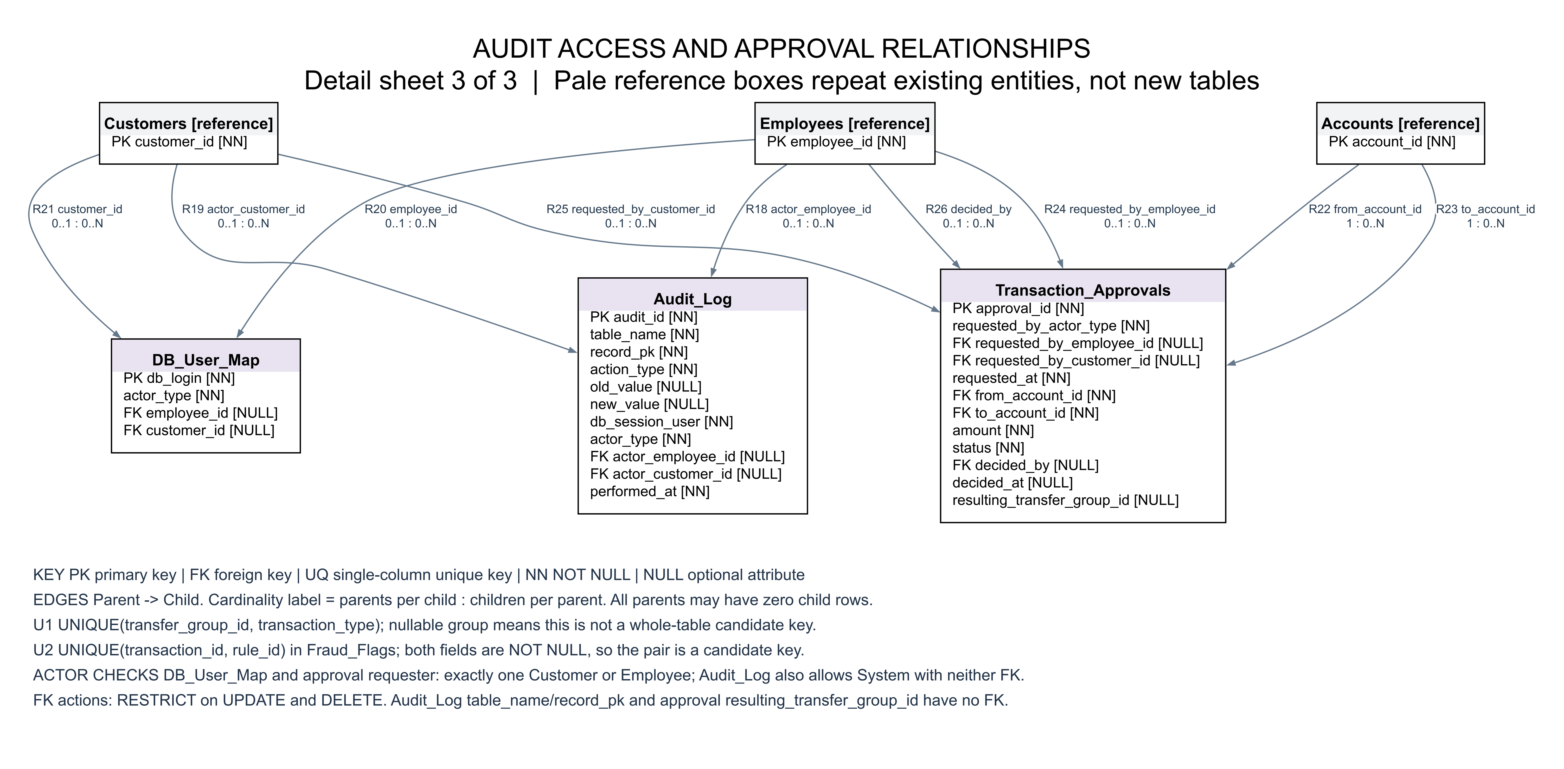
ER detail 3. Audit access and approval relationships

